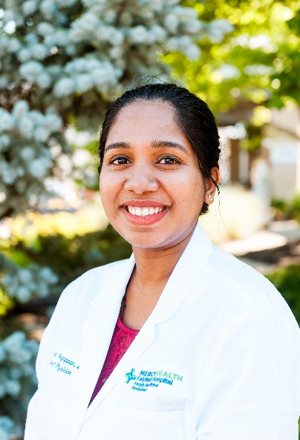  Aiswarya Nagappan, MD | Undergraduate: AUA, Major: Bachelor of Health and Human Sciences  Medical School: American University of the Caribbean School of Medicine  Medical Interests: Outpatient primary care with office-based procedures, lifestyle medicine, and preventive medicine. I enjoy helping patients stay healthy through prevention while building long-term relationships with them.  Hobbies: I love traveling; I’ve explored 13 countries so far and counting, I also enjoy hiking and discovering new cuisines.  Why I chose Mercy Health Fairfield:  From the moment I interviewed at Mercy Health Fairfield, I knew there was something different about this program. The attendings weren't just interviewing me, they were genuinely interested in who I was, my career goals, and how they could help me become the physician I wanted to be. It felt like home from day one.  Now that I'm here, I can confidently say that feeling was spot on. The attendings are incredibly supportive, always willing to teach, and truly invested in our success. Even better, my co-residents quickly became some of my closest friends. Within weeks, we were grabbing dinner, exploring places, and finding every excuse to hang out. Residency can be challenging, but having a group of people who support each other, laugh together, and genuinely enjoy spending time together has made this experience incredibly rewarding. I couldn't imagine training anywhere else.
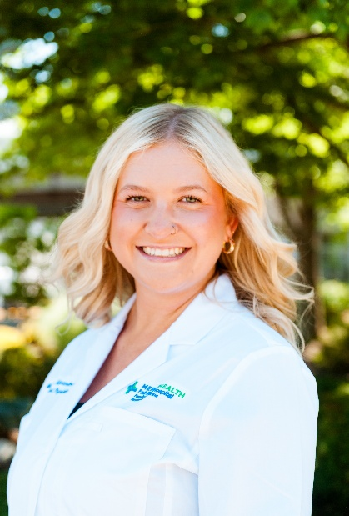  Madison Alexander, MD | Undergraduate: Wright State University- Biological Sciences  Medical School: Wright State University Boonshoft School of Medicine  Medical Interests: Geriatrics, Women's health, Preventative medicine  Hobbies: Spending time with family, reading, playing with my goldendoodle, sand volleyball  Why I chose Mercy Health Fairfield:  Fairfield stems from the genuine warmth, encouragement, and strong sense of community shared by the faculty. The program's exceptional commitment to hands-on teaching and broad-scope training provides the ideal foundation to grow into a skilled, empathetic family physician dedicated to serving our diverse patient population.
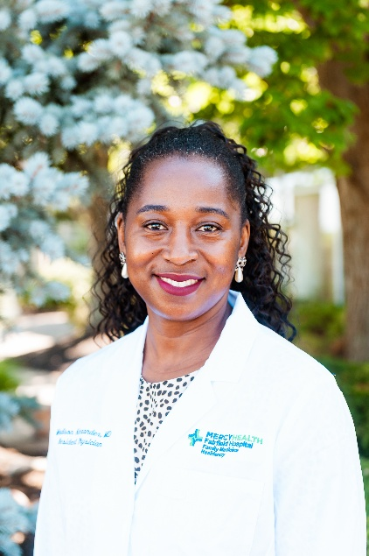  Nina Vekima, MD, MBA | Undergraduate School: Eastern Michigan University  Medical School: Avalon University School of Medicine, Curaçao  Medical Interests: My clinical interests include Lifestyle and Preventive medicine, with a focus on helping patients achieve optimal health through disease prevention, patient education, and evidence-based care. My research interests include Clinical research and Drug development, where I am passionate about advancing innovative therapies and translating research into improved patient outcomes.  Hobbies: Hiking, traveling, exploring new cuisines, and spending time with family.  Why I Chose Mercy Health Fairfield:  I chose Mercy Health because of its commitment to compassionate, patient-centered care, exceptional family medicine training, and a supportive learning environment. The program's emphasis on serving diverse communities, fostering professional growth, and developing well-rounded family physicians aligns with my passion for preventive medicine, lifelong learning, and delivering high-quality, evidence-based patient care.
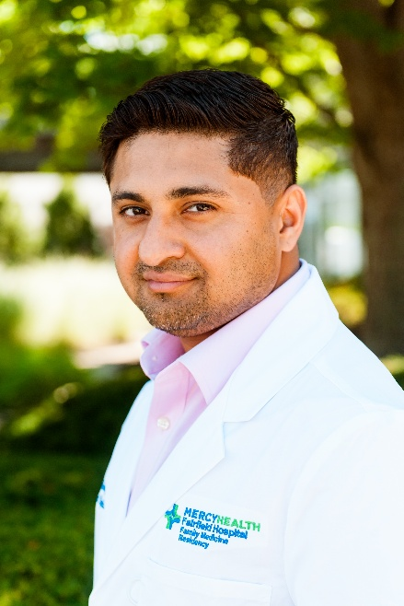  Subash Acharya, MD | Undergraduate: Syracuse University; Major: Biology, Minor: Psychology  Medical School: American University of Antigua College of Medicine  Medical Interests: Full-spectrum family medicine across all ages, including hospital medicine, outpatient care, pediatrics, obstetrics, POCUS, procedures, and lifestyle medicine.  Hobbies: Traveling, Soccer, bowling, writing poetry, photography, content creation, and spending quality time with my family.  Why I chose Mercy Health Fairfield: I chose to pursue my training at Mercy Health Fairfield because it is my local hometown program. During the recruitment process, the faculty and staff were genuinely welcoming and showed immense interest in me as a candidate. I am excited to be surrounded by such great people and to have the unique opportunity to help shape the culture as a member of the program's inaugural class.
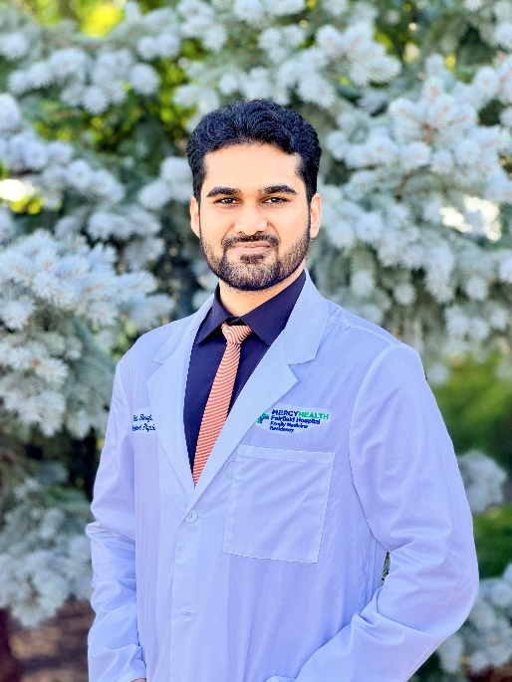  Ihab Hanafi, MD | Undergraduate: Spartan Health Sciences University, School of Arts and Science  Major: Biochemistry  Medical School: Spartan Health Sciences University, School of Medicine  Medical Interests: Lifestyle Medicine, Integrative Medicine and Obesity Medicine  Hobbies: Outside of work, I enjoy playing guitar and unwinding with video games. I’m passionate about music and love exploring different genres and diving deep into artists’ discographies. I love traveling: exploring new places, experiencing different cultures, and trying a wide range of cuisines. I also enjoy watching sports and am a lifelong FC Barcelona supporter (Força Barça!)  Why I chose Mercy Health Fairfield: Mercy Health Fairfield stood out to me because it offered everything I was looking for in a residency. Meeting the faculty made their passion for teaching and building an outstanding program immediately clear. Being part of the founding residency class, with the unique training and skills that come with it, was especially compelling. Above all, the culture surrounding the program left me feeling confident that this is where I want to train.
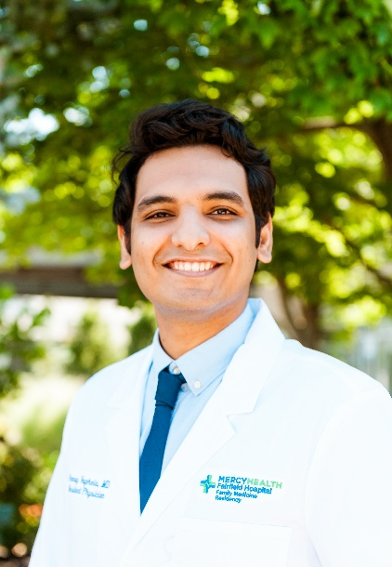  Pranay Vaghela MD | Undergraduate: The Maharaja Sayajirao University of Baroda, Gujarat, India  Medical School: GMERS Medical College  Medical interests: Preventative, Lifestyle, Sports, Addiction  Hobbies: Soccer, F1, Traveling, Trail walking  Why I chose Mercy Health Fairfield: The welcoming people, the supportive learning environment, and the opportunity to help build something meaningful as part of an inaugural class made Mercy Health an ideal choice for me.

