Podiatry Surgical Residents 2024-2025
3rd Year Residents PGY-3
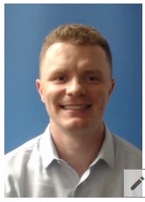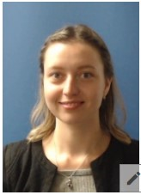
Neil Bernard, DPM Angelika Sheiman, DPM
2nd Year Residents PGY-2
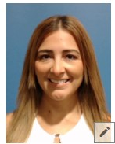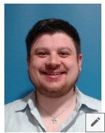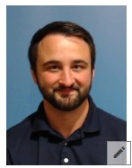
Sylvette Gelabert-Baez, DPM Andrew Shall, DPM Austin Slates, DPM
1st Year Residents PGY-1
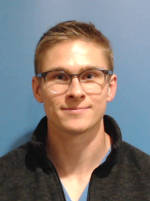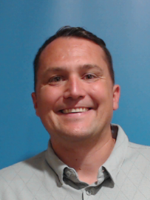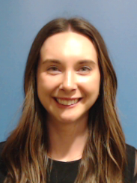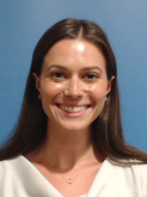
David Coffey, DPM Stephan Jokic, DPM Lauren Pekar, DPM Halle Strachan, DPM

